7th January 2020

**Title:**

**Year 2020 Brings Luck to Six Expats to win Dubai Duty Free’s US$1 Million promotions and Five Luxury Vehicles**

**Summary:**

The lucky Millennium Millionaire winner was Mrs. Dana R., a 33-year-old American national based in Dubai, who just became a US$1 million richer in Series 320 with ticket number 3680.

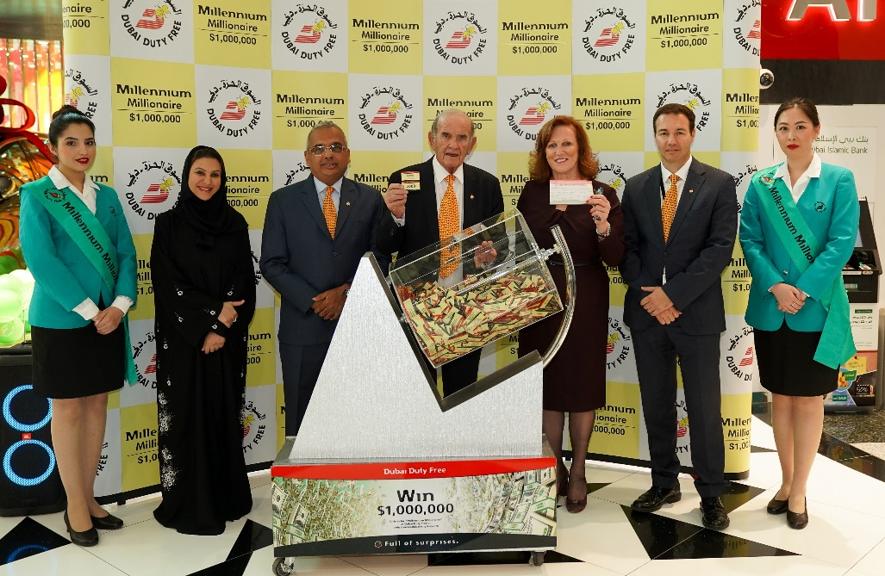

The Dubai Duty Free Millennium Millionaire draw for Series 320 was conducted by Colm McLoughlin, Executive Vice Chairman & CEO, Ramesh Cidambi, COO, Sinead El Sibai, SVP – Marketing, Mona Al Ali, SVP - HR and Michael Schmidt – SVP Retail Support.

A Dubai Duty Free representative was surprised to receive a call from the latest Millennium Millionaire winner in Series 320 who happened to witness the live draw in Dubai Duty Free official Facebook page which was held this morning in Concourse C.

The latest Dubai Duty Free Millennium Millionaire and Finest Surprise draw was conducted by Colm McLoughlin, Executive Vice Chairman & CEO, Ramesh Cidambi, COO, Sinead El Sibai, SVP – Marketing, Mona Al Ali, SVP - HR and Michael Schmidt – SVP Retail Support.

The lucky Millennium Millionaire winner was Mrs. Dana R., a 33-year-old American national based in Dubai, who just became a US$1 million richer in Series 320 with ticket number 3680.

Mrs. R, the first million-dollar winner in 2020, bought her lucky ticket for the first time from a Dubai Duty Free Finest Surprise counter in Dubai International Airport when she travelled to Bahrain in December for a one-day trip to attend a baby shower. A resident of Dubai for 30 years, Mrs. R who works for a holding company, has been buying tickets online for the past 3 months, said: “I am very happy that I have won, this only shows that the Dubai Duty Free promotion is a credible draw. What a good start for 2020, thank you so much Dubai Duty Free!”

Mrs. R. is the eighth American national to win the promotion since its inception in 1999.

Following the Millennium Millionaire draw, two cars and three motorbike winners were also announced.

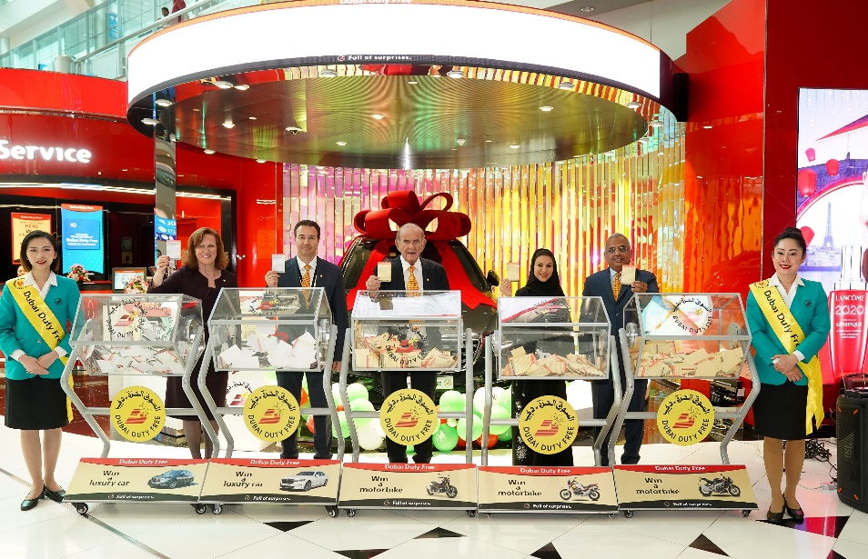

The latest Dubai Duty Free Finest Surprise draw for two cars and three motorbikes was conducted by Colm McLoughlin, Executive Vice Chairman & CEO, Ramesh Cidambi, COO, Sinead El Sibai, SVP – Marketing, Mona Al Ali, SVP - HR and Michael Schmidt – SVP Retail Support.

Mr. Omar Jalal Alwo, a 40 year-old Syrian national living in Dubai became the proud owner of BMW 750Li xDrive M Sport (Mineral White) in Series no. 1741 with ticket 0211. A resident of Dubai for 20 years Mr. Alwo works for Dubai Municipality and bought his first ever ticket when he travelled to Damascus for a short holiday.

“I would like to thank Dubai and Dubai Duty Free for this big gift which makes me so happy. I didn’t expect to win this early with my first ever ticket to your amazing promotion.”

Meanwhile, Mr. Salem Yaqub, a 35 year old Bangladeshi national based in Ajman won a Mercedes Benz S560 (Obsidian Black) in Series no. 1742 with ticket number 1127. Born and raised in Ajman, Mr. Yaqub, owner of the Salem Shopping Center in Ajman has been buying tickets online for the Dubai Duty Free promotions for a year now.

“Thank you so much Dubai Duty Free. It is always a turning point and I never thought I would win one day!”

Mr. Mark Louie Celestino, a Filipino national based in Sharjah won an Indian FTR 1200S motorbike (Red/Black) in Series 392 with ticket number 0404. Mr. Celestino is currently on holiday and will be surprised when he finds out of his win.

Mr. Samir Dewan Rai, a 42 year old Nepali national based in Dubai won a Moto Guzzi V85 TT motorbike (Giallo Sahara) in Series 393 with ticket number 0264. A resident of Dubai for 10 years now, Mr. Rai who works as a senior customer service for Emirates Airline in Dubai International Airport bought one of the last 3 tickets for Series 393 in Dubai Duty Free Finest Surprise counter in Concourse B on 20th December, which was the last day of the retailer’s 25% discount offer during its 36th anniversary promotion.

A regular participant to Dubai Duty Free’s promotions since 2016, Mr. Rai couldn’t believe his luck and commented: “Thanks so much Dubai Duty Free! I will try again in the hope to finally win the US$1 million and I will encourage my colleagues and friends to do the same.”

Lastly, Mr. Idrees Gatta, a Pakistani national living in Dubai won a Moo Guzzi V7 Racer motorbike (Racer) in Series 394 with ticket number 0125. He is currently unavailable for comment.

* Ends –

For further information, please contact Bernard Aquino, Marketing Department,

Dubai Duty Free or call Tel: +9714-6019232 or email: [bernard.aquino@ddf.ae](mailto:bernard.aquino@ddf.ae)